

**2022 Jan – 2023 Jan**

**CV Curriculum**

**The Computer Guy**

**of Moshugi Gakenamotse Henry**

**CURRICULUM VITAE**

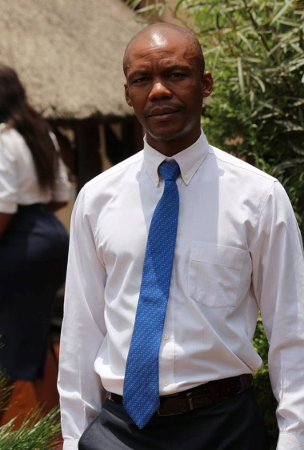**CURRICULUM VITAE OF**

**Moshugi Gakenamotse Henry**

**Contact Information**

**Residential Address:** 614 Dikole Section, Katlehong, 1431

**E-mail Address:** [henry.g.moshugi@gmail.com](mailto:henry.g.moshugi@gmail.com); henry.g.moshugi@outlook.com

**Contact Number:** +27 (0)62 301 9663

**Personal Information ■ Marital Status :** Single

**■ Nationality :** South African

**■ Health Status :** Good

**■ Gender :** Male

**■ Criminal Offence :** None

**■ Date of Birth :** 1971 March 16

**■ Identity Number :** 710316 5833 08 3

**■ Home Language :** Setswana

**■ Other Language(s) :** English, Afrikaans, S. Sotho, and Xhosa/Zulu

**Secondary Education ■ Name of School :** Kwadukathole Comprehensive School

**■ Highest Grade Passed:** Grade 11

**■ Subjects Contained : ✔** Tswana

**✔** English

**✔** Afrikaans

**✔** Mathematics

**✔** Physical Science

**✔** Biology

**■ Year Completed :** 1995

**Further Education ■ Name of Institution :** Microtech Computer Campus

**■ Qualification :** *Diploma in*:-

Computer Engineering (A+)

*Diploma in:-*

Advanced MS Windows & Office,

Data Capturing, Office Administration

with Pastel ver.5

**■ Year Obtained :** 2000

**■ Name of Institution :** Thuthukani Community Literacy Project

**■ Qualification :** Certificate inPlumbing

**■ Year :** 2000 – 2001

**Employment ■ Name of Company :** Thuthukani Community Literacy Project

**Information ■ Position :** Computer Technician, Facilitator and

Graphic Designer

Member of Executive Committee (Treasure)

**■ Year :** 2000 – 2003 June then

From 2003 Nov - 2006

**■ Name of Company :** Themba Sibeko Nkosi Inc

Now Called Nkosi Nkosana Inc

**■ Position :** Legal Secretary & IT Technician

**■ Year :** 2003 June – 2003 October

**■ Name of Company :** Ezomdabu Property International

**■ Position :** Office Administrator & PC Technician

**■ Year :** 2007 – 2008 Jan

**■ Name of Company :** NEOSA/Madibo Development Solutions

**■ Position :** Manager, Computer Technician,

Facilitator and Graphic Designer

**■ Year :** 2008 Feb – 2010

**Currently ■ Name of Firm : ✔** Endless Hope Bible Church *of* Bishop I

Makamu

**✔** Makamu TV,

**✔** iMakamu Funerals

**■ Position :** IT Technician, Office Administration,

and Maintenance

**■ Year :** 2016Feb to date even year

**Reference Information ■ Name of Company :** Thuthukani Community Literacy Project

**Name of Person :** Mr Happy Mabaso

**Position :** Founder/Owner

**Contact Number(s) :** 082 412 5983

**■ Name of Company :** Ezomdabu Property International

**Name of Person :** Mr Ndlela Arthur

**Position :** Founder/Owner

**Contact Number(s) :** 073 781 8835

**■ Name of Company :** NEOSA/Madibo Development Solutions

**Name of Person :** Mr Madibo Paul

**Position :** Founder/Owner

**Contact Number(s) :** 072 082 9600

**■ Name of Company :** Themba Sibeko Nkosi Inc

Now Called Nkosi Nkosana Inc

**Name of Person :** Mr. Nkosana Nkosi

**Position :** Director/Founder

##### Contact Number(s) : Tel: +27 (0) 11 823 1898 or

##### Cell: +27 (0) 78 165 5680

**■ Name of Company :** Endless Hope Bible Church

**Name of Person :** Mrs. H Makamu

**Position :** HR

**Contact Number(s) :** 087 720 1029

IT Technician doing general IT duties:-

1. Setup devices (Switches, Routers, AP Wi-Fi, IP Phones, Desktop Computers etc)
2. Diagnose devices
3. Repair or advice what is needed for the repair of the devices
4. Software (CHM, Website domain, Cpanel, Wordpress, rtp, html language, Third party firewall with dhcp, IP Management etc)
5. Ensure that every service of the church is prepared in regard with video shooting, internet, streaming systems, screens displays system, worshiping system, electricity and others

Administration, doing general Office Administration duties:-

1. Filing documents of the church using admin system of fontana software which is adminpro
2. Filing documents of the members of the church using admin system of fontana software which is adminpro
3. Capture information/data of members of the church using admin system of fontana software which is adminpro
4. Capture finance/offerings of the members of the church using admin system of fontana software which is adminpro
5. Monitor existence and participation of the members of the church
6. Plan and manage activities instructed by Bishop of the church to members of the church
7. Retrieve/report summary of the members of the church using admin system of fontana software which is adminpro